EMEA Gallagher Email Signature Template
The Gallagher email signature is standardized across all regions and divisions and should be used by all Gallagher employees without altering formatting or components.
Disclosures are generated through UK network preferences and are not included in the email signature template.

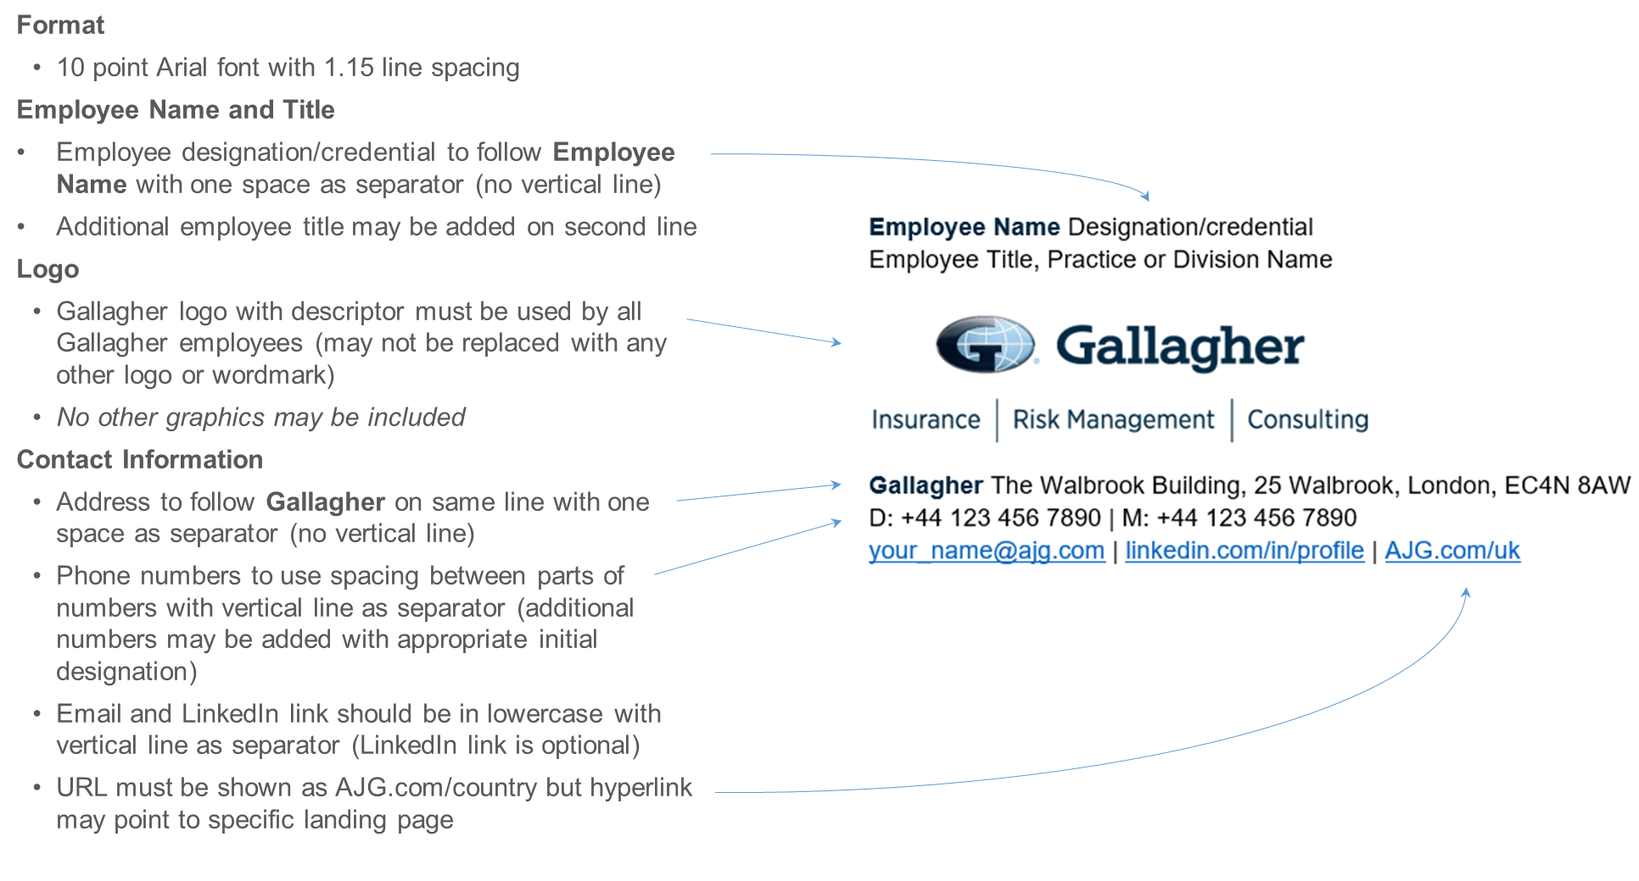

To customize your personal Gallagher Email Signature, select one of the following links:
- Gallagher - EMEA
- Gallagher - EU
- Merger Partners
Additional Resources:
- Referral or Promotional Callout variation
- Abbreviated format for replies/forwards
- Microsoft Outlook Instructions
- Color and Font Specifications

Gallagher Employee – Template
Gallagher employees should customize this template with their personal contact information to use as their Microsoft Outlook Signature per provided instructions. Within EMEA, disclaimers are generated through the UK network preferences and are not included in the email signature template. Copy this template and paste using “Keep Source Formatting” option. Do not attempt to replicate formatting manually.
- Standard Gallagher logo may not be replaced with any other logo or wordmark
- No other graphics may be included
- Additional numbers such as toll free, fax, etc., may be included with appropriate initial designation
- LinkedIn profile link is optional
- URL must be shown as AJG.com/country but hyperlink may point to specific landing page

Employee Name Designation/credential
Employee Title, Practice or Division Name
Gallagher The Walbrook Building, 25 Walbrook, London, EC4N 8AW
D: +44 123 456 7890 | M: +44 123 456 7890
your_name@ajg.com | linkedin.com/in/profile | AJG.com/uk

EU Email Signature Templates
Please see dedicated EU Email Signature Template document to ensure all requirements are included.
Merger Partners
Merger partners fully transitioned to the Gallagher name and brand should use the standard Gallagher email signature as directed in this document.
Merger partners not yet transitioned to the Gallagher name and brand should continue using their existing brand email signature, updated with any required legal disclaimer.
Please direct any merger partner related questions to Olivia Campbell.

Referral or Promotional Callout Variation – Template
If necessary, employees may include ONE callout, such as to promote an endorsement or specific initiative, in their email signature.
- Only one callout may be included (may not include any graphics)
- Callout should be limited in length (10-20 words) and include only one hyperlink
- Must be added below contact information in 10 point Arial font in Web Compliant Secondary Orange (RGB Color: R 223, G 101, B 52)

Referral Request Example

Employee Name Designation/credential
Employee Title, Practice or Division Name
Gallagher The Walbrook Building, 25 Walbrook, London, EC4N 8AW
D: +44 123 456 7890 | M: +44 123 456 7890
your_name@ajg.com | linkedin.com/in/profile | AJG.com/uk

The highest compliment you can pay us is the introduction of new clients. If you know someone who would benefit from our service, we would very much appreciate your recommendation.

Promotional Callout Example

Employee Name Designation/credential
Employee Title, Practice or Division Name
Gallagher The Walbrook Building, 25 Walbrook, London, EC4N 8AW
D: +44 123 456 7890 | M: +44 123 456 7890
your_name@ajg.com | linkedin.com/in/profile | AJG.com/uk

Gallagher is proud of its commitment to Inclusion and Diversity | Learn More
Replies / Forwards Abbreviated Email Signature – Template
Employees may customize this abbreviated template with their personal contact information to use for Replies / Forwards as their Microsoft Outlook Signature. As applicable, CA license numbers, legal name and disclosures must be included as shown in standard template.

Employee Name Designation/credential
Employee Title, Practice or Division Name
D: +44 123 456 7890 | M: +44 123 456 7890
your_name@ajg.com | linkedin.com/in/profile | AJG.com/uk

[Legal Entity]

[Regulatory Disclosure]

Microsoft Outlook Instructions

- Within Microsoft Outlook, go to: File Tab > Options > Mail > [Signatures…]
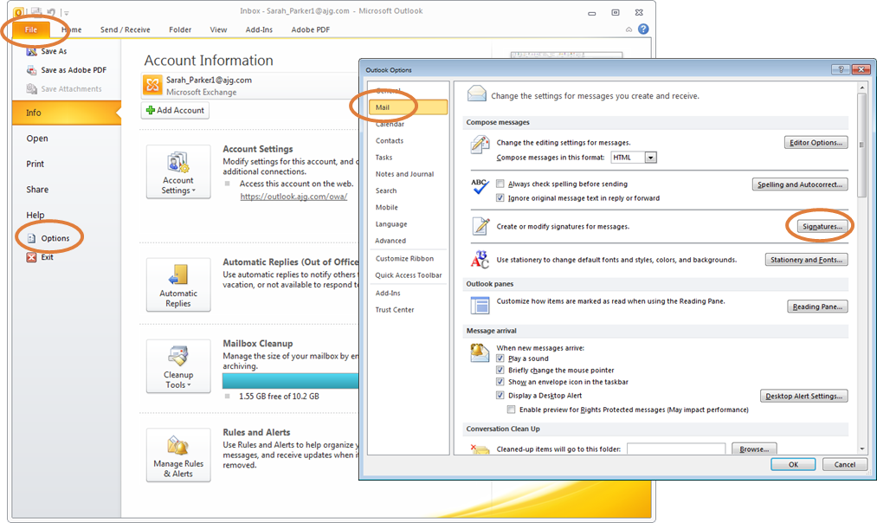
- Within the Signatures Window, click [New]. Type a name for the signature and click [OK].
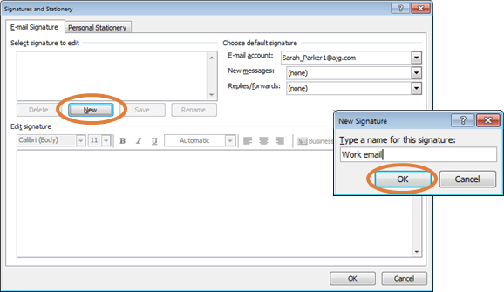
- Copy the appropriate email signature template in this document.
- Within the Signatures Window, right click in the signature box and select the “Keep Source Formatting” paste option.
UPDATE ALL CONTACT INFORMATION WITH YOUR PERSONAL INFORMATION INCLUDING EMAIL ADDRESS AND PHONE NUMBERS. Click [OK] to save.

Gallagher Email Signature Font and Color Specifications

Name: 10 Point Arial Bold, Gallagher Dark Blue (RGB Color: R 0, G 38, B 62)
Title: 10 Point Arial, Black
[Gallagher Logo: 1.05” High x 3” Wide; USE LOGO PROVIDED IN THIS DOCUMENT]
Phone(s) / Email / LinkedIn / Website: 10 Point Arial, Black
Gallagher: 10 Point Arial Bold, Gallagher Dark Blue (RGB Color: R 0, G 38, B 62)
Address: 10 Point Arial, Black
Optional Callout: 10 Point Arial, Web Compliant Secondary Orange (RGB Color: R 223, G 101, B 52)
Legal Name: 10 Point Arial, Web Compliant Secondary Gray (RGB Color: R 137, G 141, B 141)
CA License Number: 10 Point Arial, Web Compliant Secondary Gray (RGB Color: R 137, G 141, B 141)
Disclaimer: 8 Point Arial, Web Compliant Secondary Gray (RGB Color: R 137, G 141, B 141)

