Gallagher Email Signature Templates and Instructions
The Gallagher email signature is standardized across all regions and divisions and should be used by all Gallagher employees without altering formatting or components.

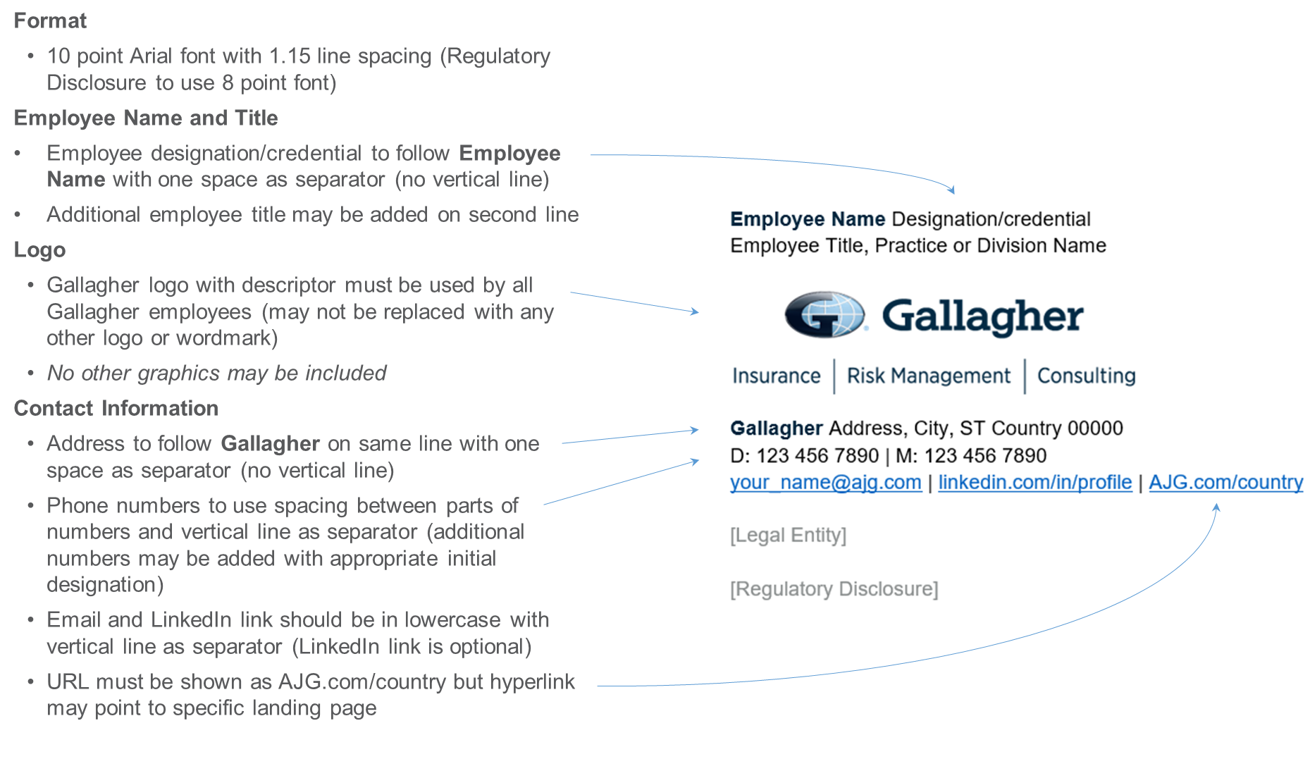

To customize your personal Gallagher Email Signature, select one of the following links:
- Gallagher – Global Template

Additional Resources:
- Promotional callout variation
- Abbreviated format for replies/forwards
- Microsoft Outlook Instructions
- Color and Font Specifications

Gallagher Global – Template
Gallagher employees located outside of the US, Canada or EMEA should customize this template with their personal contact information to use as their Microsoft Outlook Signature per provided instructions. Copy this template and paste using “Keep Source Formatting” option. Do not attempt to replicate formatting manually.
Please confirm with your local compliance team if email disclaimers are auto-generated and/or insert your local legal entity and required disclaimer as shown below as required.
- Standard Gallagher logo may not be replaced with any other logo or wordmark
- No other graphics may be included
- Additional numbers such as toll free, fax, etc., may be included with appropriate initial designation
- LinkedIn profile link is optional
- URL must be shown as AJG.com/country but hyperlink may point to specific landing page

Employee Name Designation/credential
Employee Title, Practice or Division Name
Gallagher Address, City, ST Country 00000
D: 123 456 7890 | M: 123 456 7890
your_name@ajg.com | linkedin.com/in/profile | AJG.com/country

[Legal Entity]

[Regulatory Disclosure]

Promotional Callout Variation – Template
If necessary, employees may include ONE callout, such as to promote an endorsement or specific initiative, in their email signature.
- Only one callout may be included (may not include any graphics)
- Callout should be limited in length (10-20 words) and include only one hyperlink
- Must be added below contact information above legal entity and disclosure in 10 point Arial font in Web Compliant Secondary Orange (RGB Color: R 223, G 101, B 52)

Employee Name Designation/credential
Employee Title, Practice or Division Name
Gallagher Address, City, ST Country 00000
D: 123 456 7890 | M: 123 456 7890
your_name@ajg.com | linkedin.com/in/profile | AJG.com/country

Gallagher is proud of its commitment to Inclusion and Diversity | Learn More

[Legal Entity]

[Regulatory Disclosure]

Replies / Forwards Abbreviated Email Signature – Template
Employees may customize this abbreviated template with their personal contact information to use for Replies / Forwards as their Microsoft Outlook Signature. As applicable, legal name and disclosures must be included as directed by local compliance team.

Employee Name Designation/credential
Employee Title, Practice or Division Name
D: 123 456 7890 | M: 123 456 7890
your_name@ajg.com | linkedin.com/in/profile | AJG.com/country

[Legal Entity]

[Regulatory Disclosure]

Microsoft Outlook Instructions

- Within Microsoft Outlook, go to: File Tab > Options > Mail > [Signatures…]
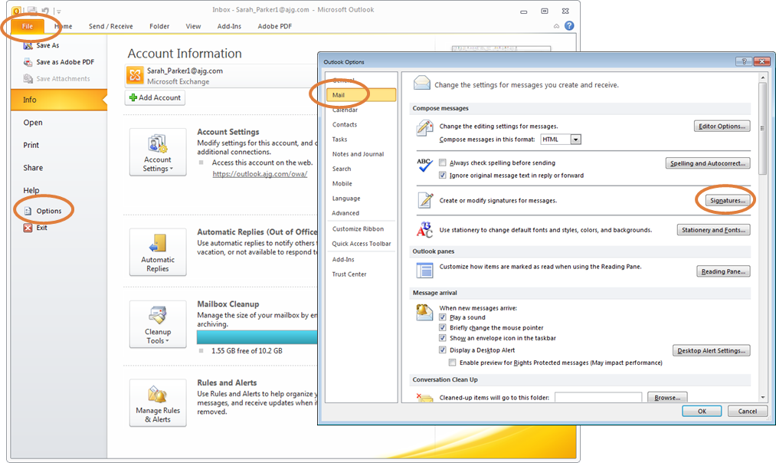
- Within the Signatures Window, click [New]. Type a name for the signature and click [OK].
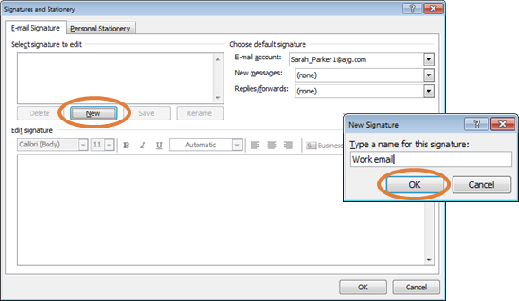
- Copy the appropriate email signature template in this document.
- Within the Signatures Window, right click in the signature box and select the “Keep Source Formatting” paste option.
UPDATE ALL CONTACT INFORMATION WITH YOUR PERSONAL INFORMATION INCLUDING EMAIL ADDRESS AND PHONE NUMBERS. Click [OK] to save.

Gallagher Email Signature Font and Color Specifications

Name: 10 Point Arial Bold, Gallagher Dark Blue (RGB Color: R 0, G 38, B 62)
Title: 10 Point Arial, Black
[Gallagher Logo: 1.05” High x 3” Wide; USE LOGO PROVIDED IN THIS DOCUMENT]
Phone(s) / Email / LinkedIn / URL: 10 Point Arial, Black
Gallagher: 10 Point Arial Bold, Gallagher Dark Blue (RGB Color: R 0, G 38, B 62)
Address: 10 Point Arial, Black
Optional Callout: 10 Point Arial, Web Compliant Secondary Orange (RGB Color: R 223, G 101, B 52)
Legal Name: 10 Point Arial, Web Compliant Secondary Gray (RGB Color: R 137, G 141, B 141)
CA License Number: 10 Point Arial, Web Compliant Secondary Gray (RGB Color: R 137, G 141, B 141)
Disclaimer: 8 Point Arial, Web Compliant Secondary Gray (RGB Color: R 137, G 141, B 141)

